Primary Admissions
New entrants to P1 are enrolled early in the calendar year for entry to school in August. This is for children who will be five on or before the school start date in the middle of August. Those whose fifth birthday is between the middle of August each year and the end of February the following year may also be admitted to P1 in August the previous year. Details of the enrolment dates are advertised in the local press by Aberdeenshire Education & Children’s Services Department.
Parents of children joining the school in classes other than P1 or in the middle of a school session should contact the head teacher who will agree a start date for the child and make arrangements for the parents and child to visit the school.

School Zone
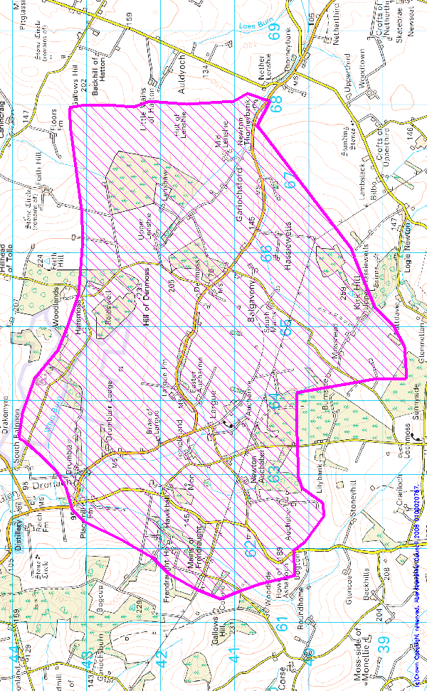
A map showing the school zone/catchment area is shown below. Please note that children who live within the school catchment zone are automatically entitled to a place in school. Please use the zone map to check whether or not you live within the Largue School catchment. If you live out with the zone, the Education (School and Placing Information) (Scotland) Regulations 2012 will allow you to seek admission to the school. The main point to note is that out of zone admissions are not guaranteed and pupils out of zone are not entitled to free transport. They are also not guaranteed a place at The Gordon Schools Academy and parents would need to submit a further placing request before transition to S1

