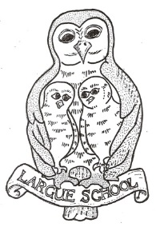
Largue School – Our Rationale for the Curriculum

Our vision for Largue School is a happy, caring environment where pupils are ambitious, creative and encouraged to achieve to their greatest potential.

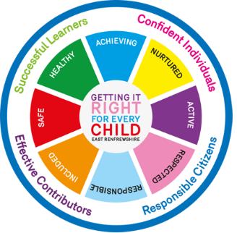
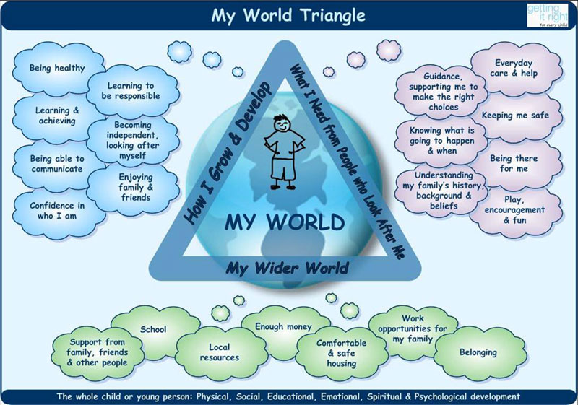
Curriculum Design Principles

- Challenge and enjoyment
- Breadth
- Progression
- Depth
- Personalisation and choice
- Coherence
- Relevance

Experiences and Outcomes
Maths and Numeracy
Languages and Literacy
Health and Wellbeing
Expressive Arts
Sciences
Social Studies
Technologies
Religious and Moral Education

Progression through Early, First, Second and Third levels throughout time at school
Entitlements
Every child and young person is entitled to
- experience a curriculum which is coherent from 3 to 18
- experience a broad general education
- develop skills for learning, skills for life and skills for work
- personal support to enable them to gain as much as possible from the opportunities which Curriculum for Excellence can provide
- develop knowledge and understanding of society, the world and Scotland's place in it
- experience challenge and success
- be active and healthy
- 2 hours of PE weekly
- Be involved in decision making
- review their learning and plan for next steps
- learn in a variety of settings, including outdoors
- Enjoy their time in school

Successful Learners

Attributes
- Enthusiasm and motivation for learning
- Determination to reach high standards of achievement
- Openness to new thinking and ideas

Capabilities
- Use literacy, communication and numeracy skills
- Use technology for learning
- Think creatively and independently
- Learn independently and as part of a group
- Make reasoned evaluations
- Link and apply different kinds of learning in new situation
Confident Individuals

Attributes
- Self-Respect
- A sense of physical, mental and emotional well-being
- Secure values and beliefs
- Ambition

Capabilities
- Relate to others and manage themselves
- Pursue a healthy and active lifestyle
- Be self-aware
- Develop and communicate their own beliefs and view of the world
- Live as independently as they can
- Assess risks and make informed decisions
- Achieve success in different areas of activity
Responsible Citizens

Attributes
- Respect for others
- Commitment participate responsibly in political, economic, social and cultural life

Capabilities
- Develop knowledge and understanding of the world and Scotland’s place in it
- Understand different beliefs and cultures
- Make informed choices and decisions
- Evaluate environmental, scientific and technological issues
- Develop informed, ethical views of complex issues
Effective Contributors

Attributes
- An enterprising attitude
- Resilience
- Self-reliance

Capabilities
- Communicate in different ways and in different settings
- Work in partnership and in teams
- Take the initiative and lead
- Apply critical thinking in new contexts
- Create and develop
- Solve problems

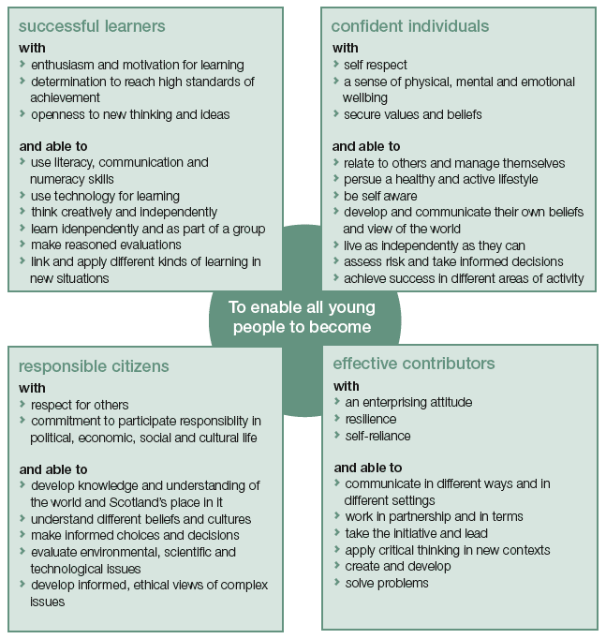

entitlements for all children and young people
1. Every child and young person is entitled to experience a curriculum which is coherent from 3 to 18
Every child and young person is entitled to experience a broad general education
- achieve the highest possible levels of literacy and numeracy and cognitive skills
- develop skills for life and skills for work

Every child and young person is entitled to develop skills for learning, skills for life and skills for work, with a continuous focus on literacy and numeracy and health and wellbeing

Every child and young person is entitled to personal support to enable them to gain as much as possible from the opportunities which Curriculum for Excellence can provide
- gain access to learning activities which will meet their needs
- plan for opportunities for personal achievement
- prepare for changes and choices and be supported through changes and choices

LARGUE SCHOOL’S VISION

LARGUE SCHOOL’S EDUCATIONAL AIMS

- The school is responsible for the overall well being and education of the children and strive to ensure that we meet the emotional physical and social needs of our children.

- We aim to provide an environment which is sufficiently challenging for the pupils, where pupils are actively involved in their own learning and development.

- To this end we work together to assist every child to have the satisfaction of achieving to the very best of their ability. We aim to continue to raise attainment and to ensure that all pupils are successful learners and confident individuals

- A rural school is like a family unit and we aim to achieve an
environment where all children are treated with kindness and tolerance and where there is a strong sense of equality and fairness

- The aim of teachers and pupils is to advance and develop in knowledge, skill and attitude to learning in a happy, caring atmosphere where individuals are respected and where our work is continually evaluated to ensure improvement.

- The school is an important part of the local community and our aims
can only be achieved fully in partnerships with parents, other agencies and the wider community.

- The maintenance of such an atmosphere is the responsibility of
everyone in the school and we strive through a wide range of activities to ensure that pupils and all stakeholders are included in the life of the school and pupils become responsible citizens and effective contributors to the school and the wider community.

